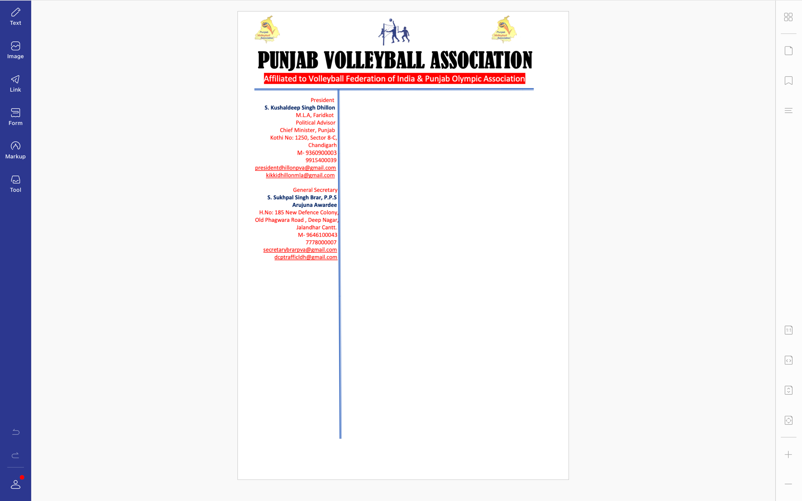



**Ref. PVA/BRAR/2021/Spl.-(2)/2010-27** Dated: 27-09-2021

v`l:

ipRMsIpl

fUn AwksPorf skUl

luiDAwxw

ivSw: sInIAr styt vwlIbwl cYNpIAniSp (mrd Aqy AorqW) iv`c kocz swihbwn (rYPrI) dI ifaUtI sbMDI

auprokq ivSy dy sbMD iv`c Awp jI nUM bynqI kIqI jWdI hY ik sInIAr styt vwlIbwl cYNpIAniSp (mrd Aqy AorqW) jo ik izlwH vwlIbwl AYsosIeySn, PrIdkot v``loN imqI 1, 2 Aqy 3 AkqUbr, 2021 idn Sukrvwr, SnIvwr Aqy AYqvwr nUM srkwrI brijMdrw kwlj, PrIdkot ivKy krvweI jw rhI hY [ ies tUrnwmYNt nUM sucwrU FMg nwl krvwaux sbMDI Awp jI dy skUl dy vwlIbwl koc SRI BuipMdr rwxw dI ifaUtI lgweI jWdI hY[ Awp jI nUM bynqI hY ik krmcwrI nUM smyN isr Pwrg krn dI ikrpwlqw kIqI jwvy[

DMnvwd sihq

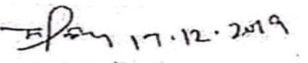

suKpwl isMG brwV, Arujnw AvwrfI

jnrl sk`qr

pMjwb vwlIbwl AYsoSIeySn